**DAILY ONLINE ACTIVITIES SUMMARY**

|  |  |  |  |  |  |  |  |  |
| --- | --- | --- | --- | --- | --- | --- | --- | --- |
| **Date:** | **22-06-2020** | | | | | **Name:** | **SRILATHA K KAMATH** | |
| **Sem & Sec** | **6 B** | | | | | **USN:** | **4AL17CS099** | |
| **Online Test Summary** | | | | | | | | |
| **Subject** | | **Programming in C/C++** | | | | | | |
| **Max. Marks** | | **-** | | **Score** | | | **-** | |
| **Certification Course Summary** | | | | | | | | |
| **Course** | **Pre-placement Training** | | | | | | | |
| **Certificate Provider** | | | **-** | | **Duration** | | | **4hours** |
| **Coding Challenges** | | | | | | | | |
| **Problem Statement:** 1. Python program to read a text file and print all the numbers present in the text file. 2. Python program to read the contents of a file in reverse order. | | | | | | | | |
| **Status: COMPLETED** | | | | | | | | |
| **Uploaded the report in Github** | | | | | **YES** | | | |
| **If yes Repository name** | | | | | https://github.com/alvas-education-foundation/Srilatha-K-Kamath-Daily-Report.git | | | |
| **Uploaded the report in slack** | | | | | **YES** | | | |

Online Test Details: -

Online Course Details:

Attended class on the topic Programming in C++. [from 9.20am to 1pm]

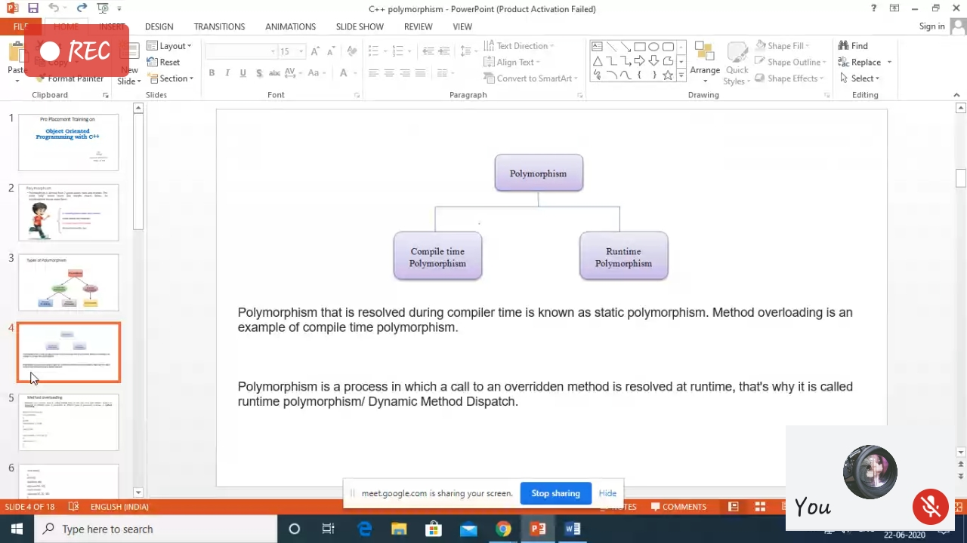

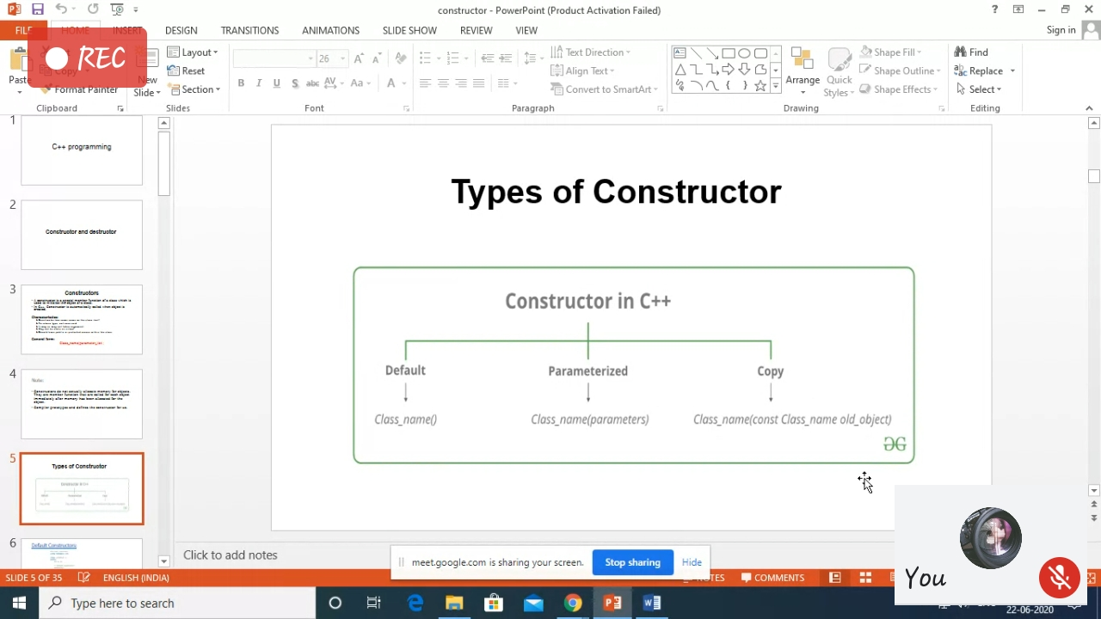

Online Coding Details: Files used to execute the Python programs.

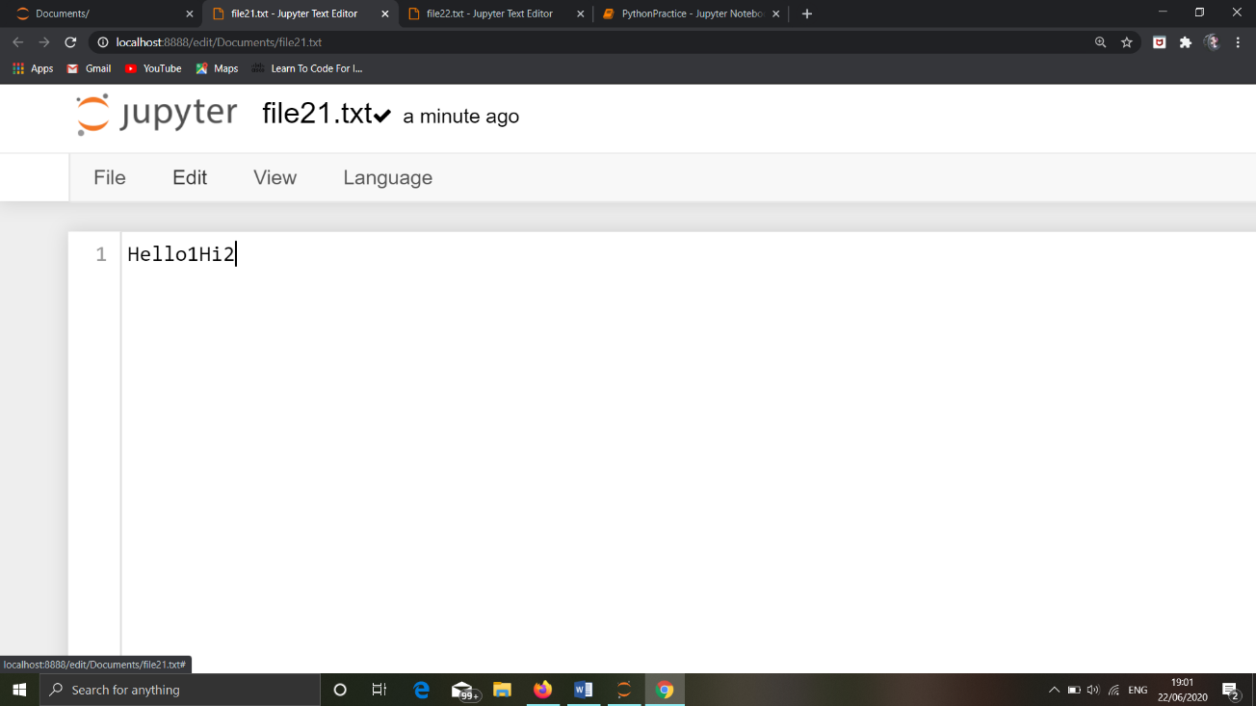

The file ‘file21.txt’ is used to execute the program which will read a text file and count the number of digits present in it.

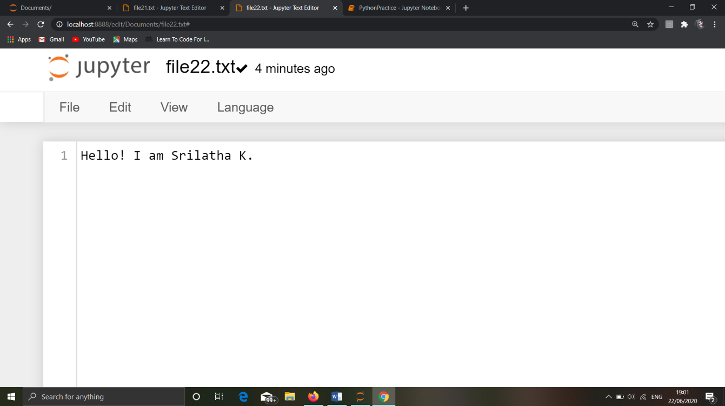

The file ‘file22.txt’ is used to execute the program which will read the contents of the file in the reverse order.

**Output:**

